“Blockchain Based E-Voting System”

SUBMITTED in partial fulfillment of the
requirement for the award of the degree
of
BACHELOR OF TECHNOLOGY
IN
COMPUTER SCIENCE & ENGINEERING

Submitted By
BIKASH CHAMUA (200610207016)
SHAMIM AKRAM (200610207061)
SHANGSIT NATH (200610007019)
ANKITA DEURI (200610007005)
Guided By
MR. PARTHA BHOWMIK
(Assistant Professor)


2020-24
ASSAM SCIENCE AND TECHNOLOGY UNIVERSITY, GUWAHATI
ASSAM ENGINEERING COLLEGE, JALUKBARI
GUWAHATI-781013
JUNE-2024
Contents
Forwarding Certificate i
Forwarding Certificate ii
ACKNOWLEDGEMENT iii
DECLARATION BY THE CANDIDATES iv
ABSTRACT v
Chapter 1- Introduction 1
1.1. Background and Context: 2
1.2. Motivation and Objectives: 3
1.3. Significance and Impact 4
Chapter 3- Project Work 5
Chapter 3.1- Methodology 6
3.1.1. Tools Required 7
3.1.2. Model Selection 10
3.1.2. Model Ready 12
Chapter 4- Results and Discussion 15
4.1. Plain Text 16
4.2. Short Text 16
4.3. Long Text 17
4.4.Handwritten Text 17
4.5. Other Languages 18
4.6. Convert Text 19
4.7. Audio Generation 19
Table 1: Result Summary 20
Chapter 5- Conclusion and Future Scope 21
Appendix 23
References 25



DEPARTMENT OF COMPUTER SCIENCE & ENGINEERING
ASSAM ENGINEERING COLLEGE::JALUKBARI
GUWAHATI-781013

Forwarding Certificate

This is to certify that BIKASH CHAMUA (200610207016), SHAMIM AKRAM (200610207061), SHANGSIT NATH (200610007019) and ANKITA DEURI (200610007005) have carried out the project work Blockchain Based E-Voting System under the supervision of Mr. Partha Bhowmik and have compiled this thesis reflecting the candidates work in the semester long project. The candidates did this project full time during the whole semester and the analysis, results, claims etc. are all related to their studies and works during the semester.
We recommend submission of this thesis as the partial fulfillment of the requirement for the degree of Bachelor of Engineering in Computer Science & Engineering of Assam Science and Technology University.

Dr. Gunajit Kalita External
Associate Professor (HOD) Name………………...
Computer Science & Engineering Signature……………...
Assam Engineering College Affiliation……………...



DEPARTMENT OF COMPUTER SCIENCE & ENGINEERING
ASSAM ENGINEERING COLLEGE::JALUKBARI
GUWAHATI-781013

Forwarding Certificate

This is to certify that BIKASH CHAMUA (200610207016), SHAMIM AKRAM (200610207061), SHANGSIT NATH (200610007019) and ANKITA DEURI (200610007005) have carried out the project work Blockchain Based E-Voting System under the supervision of Mr. Partha Bhowmik and have compiled this thesis reflecting the candidates work in the semester long project. The candidates did this project full time during the whole semester and the analysis, results, claims etc. are all related to their studies and works during the semester.
We recommend submission of this thesis as the partial fulfillment of the requirement for the degree of Bachelor of Engineering in Computer Science & Engineering of Assam Science and Technology University.

Mr. Partha Bhowmik
Assistant Professor
Signature ……………………...
Computer Science & Engineering
Assam Engineering College, Jalukbari
Guwahati - 781013

Jalukbari , Guwahati - 781013

ACKNOWLEDGEMENT

This project was an excellent learning opportunity for us. We would like to thank everyone who assisted us with this project. First and foremost, we would like to express our heartfelt gratitude to our principal Dr. Kalyan Kalita Sir, the H.O.D of Computer Science and Engineering Department Dr. Gunajit Kalita Sir and the entire Computer Science and Engineering Department. It was a positive experience. We would like to express our sincere gratitude to Mrs. Dharitri Talukdat Maam of Computer Science and Engineering Department, Assam Engineering College for her valuable assistance and guidance throughout the project. Mrs. Dharitris expertise and insights were instrumental in shaping the initial stages of the project. Her suggestions and feedback during our interactions provided valuable perspectives, which helped us in refining our ideas and establishing a solid foundation for the system. Additionally, Mrs. Dharitri's willingness to spare her time for discussions and clarifications contributed to our understanding of the project's scope and objectives. Her inputs were invaluable in helping us identify potential challenges and devising suitable strategies to overcome them. Finally, we would like to thank all the team members for their cooperation, which enabled us to complete this project within stipulated time.


Assam Engineering College
DEPARTMENT OF COMPUTER SCIENCE AND ENGINEERING
ASSAM SCIENCE AND TECHNOLOGY UNIVERSITY,GUWAHATI

DECLARATION BY THE CANDIDATES

We PULAKESH MALAKAR Roll No 20/387, **NAME** Roll No 20/156, **NAME** Roll No. 20/324 and **NAME** Roll No. 20/399 B.Tech Students of the Department of Computer Science & Engineering, Assam Engineering College hereby declare that we have compiled this thesis reflecting all our works during the project as a part of our B. Tech curriculum.
We declare that we have included the descriptions etc. of our project work, and nothing has been copied from other’s work. The facts, figures, analysis, results, claims etc. depicted in our report are all related to our full-time project work.
We also declare that the same report or any substantial portion of this project report has not been submitted anywhere else as part of any requirements for any degree etc

Date: Roll No…...………...Name…………………. Signature.……………….
Roll No…...………...Name…………………. Signature.……………….
Roll No…...………...Name…………………. Signature.……………….
Roll No…...………...Name…………………. Signature.……………….

ABSTRACT

This project introduces a user-friendly application that leverages Optical Character Recognition (OCR) technology to bridge the language barrier and enhance accessibility for digital text within images. We utilize Tesseract, a powerful open-source OCR engine, to extract text from uploaded images. The extracted text can then be translated into a wide range of languages, empowering users to comprehend information regardless of the original language used in the image. Additionally, the application integrates Google Text-to-Speech (gTTS), allowing users to listen to the extracted text as an audiobook, promoting accessibility for visually impaired users or those who prefer auditory learning. This all-in-one solution caters to diverse user needs, offering functionalities like text extraction, language translation, and text-to-speech conversion within a single, user-friendly interface. The project aims to break down language barriers and improve access to information for a wider audience.

Chapter 1- Introduction
  - Background and Context:
Optical Character Recognition (OCR) technology has become increasingly important in recent years. It allows computers to extract text from images, enabling a wide range of applications such as document scanning, image captioning, and accessibility tools for visually impaired users. This project explores the use of Tesseract, a popular open-source OCR engine, for text detection and conversion into audio format. Tesseract offers a powerful and versatile tool for extracting text data from images.
This project explores the combination of text detection and audio generation for creating a versatile tool. We leverage the capabilities of Tesseract, an Optical Character Recognition (OCR) engine, to extract text from images. The detected text is then converted into an audio format using a text-to-speech library. This approach allows users to access information within images through an auditory interface, enhancing accessibility and providing an alternative method of content consumption. The project demonstrates the power of combining computer vision and text-to-speech functionalities, potentially benefiting individuals with visual impairments or those who prefer audio-based information access.
By combining OCR technology with text-to-speech conversion, this project offers a valuable tool for transforming visual information into an accessible audio format, promoting inclusivity and enriching user experience.

  - Motivation and Objectives:
In today's digital world, information is increasingly presented in image formats, from scanned documents and screenshots to product packaging and signage. While this can be visually convenient, it can create accessibility challenges for individuals with visual impairments or those who prefer audio consumption. This project is motivated by the desire to bridge this gap and create a more inclusive information access experience.
Our project aims to develop a user-friendly system that combines three key technologies: text detection with PyTesseract, text-to-speech synthesis for audio generation, and a Flask-based web interface. By utilizing PyTesseract, the system will be able to accurately extract text from images uploaded by the user. This extracted text will then be converted into natural-sounding audio using a text-to-speech engine, allowing users to consume the information in their preferred format. Finally, the project will create a web interface built with Flask, providing a user-friendly platform for interacting with the text detection and audio generation functionalities. This web interface will eliminate the need for software installation and allow users to access the application from any device with a web browser.
Overall, this project aims to achieve the following objectives: Enhance information accessibility; by converting visual text to audio, the project caters to users with visual impairments or those who prefer audio for information consumption. Improve user experience, The web interface provides a convenient and user-friendly platform for text extraction and audio generation. Bridge the gap between visual and auditory information, The project promotes inclusivity by offering an alternative approach to accessing information from images. This combination of technologies has the potential to be a valuable tool for a wide range of users, promoting a more accessible and inclusive digital environment.

  - Significance and Impact
This project holds significant potential for improving accessibility and information extraction across various user groups. By leveraging PyTesseract for accurate text detection within images and integrating text-to-speech generation, it transforms visual information into a universally consumable format. This caters not only to those with visual impairments or reading difficulties, but also expands access to information for individuals who learn better through audio or who find themselves in situations where on-screen viewing is limited. Imagine a student on their commute being able to listen to the text extracted from a textbook image, or someone following a complex recipe being able to hear the instructions hands-free. The user-friendly Flask web interface further broadens the project's reach, making it accessible through any standard web browser, eliminating the need for software downloads or installations. This project has the potential to be a valuable tool in educational settings, for visually impaired individuals, and anyone who simply prefers the convenience of audio information delivery.
Beyond its immediate benefits for accessibility, this project lays the groundwork for more advanced applications in the field of information processing. The ability to efficiently extract text from images opens doors for tasks like automatic document processing, image-based data extraction, and even real-time text recognition in scenarios like live broadcasts or signage reading. Imagine a visually impaired individual being able to point their smartphone camera at a restaurant menu and have the text read aloud to them. This project can be a stepping stone towards a future where visual information seamlessly translates into a format accessible to everyone, regardless of their visual abilities or preferred learning style. The combination of text detection, audio generation, and a user-friendly web interface paves the way for innovative solutions that bridge the gap between visual and auditory information access, fostering a more inclusive and information-rich environment for all.

Chapter 3- Project Work

Chapter 3.1- Methodology

3.1.1. Tools Required

- Python
Python is a popular programming language known for its ease of use and versatility.Python's syntax is clear and reads almost like natural language,Despite its simplicity,Python can handle complex tasks.It's used for web development,data analysis,machine learning (including image detection!) and more.Python boasts a vast collection of pre-written code (libraries) for various functionalities.This saves you time by providing ready-made tools for common tasks.Python is free to use and modify,with a large and active community that contributes to its development and provides support.Python's simplicity and strong libraries make it ideal for our image detection project.Its clear syntax lets us develop code quickly, while libraries like OpenCV handle image loading, manipulation, and even pre-trained object detection models. This saves us time and effort, allowing us to focus on the core detection task. Python's active community also ensures ample resources for troubleshooting and learning.
- Flask
Flask is a lightweight web framework written in Python. Unlike larger frameworks, Flask focuses on being simple and easy to use. It provides the core building blocks for web applications, like handling URLs and connecting to databases, but lets you choose additional features from libraries as needed. This makes Flask flexible and ideal for quickly building small to medium-sized web apps.FLask prioritizes developer experience, making it popular for rapid prototyping, APIs, and lightweight web applications. Flask can be a great tool for building a text detection project. Flask's minimalist approach lets you develop a web app quickly without complex configurations. You can integrate powerful computer vision libraries like OpenCV for image processing and text detection algorithms. Flask can create a user-friendly interface using HTML and Javascript. Flask handles user interactions and routes image data to your text detection code.This code, written in Python, would likely use OpenCV and an OCR (Optical Character Recognition) engine like Tesseract to locate and recognize text within the image. Extracted text can be displayed on the web app for easy viewing or further processing. In essence,Flask provides the web framework to connect user input with your text detection logic, making it a valuable tool for creating a text detection project.

- Flask DropZone
Flask-Dropzone is a tool that simplifies adding drag-and-drop file uploads to your Flask web applications. It combines two technologies:
- Flask: A Python framework for building web applications.It handles things like routing and templating.
- Dropzone.js: A JavaScript library that turns a browser area into a drag-and-drop zone for files.It provides features like progress bars and image previews.
Flask-Dropzone makes it easy to integrate these two. You install it like any other Python package and configure it in your Flask app. Then you can use Jinja templates to create the upload zone on your webpage. Uploaded files are handled by Flask routes, allowing you to save them or process them further. Overall, Flask-Dropzone saves you time by giving you a pre-built solution for drag-and-drop file uploads in Flask.
- WTForms
WTForms is a Python library that simplifies creating and managing forms in web development. It works with different web frameworks and template engines, giving you flexibility in building your application. WTForms helps you with:
- Form creation: Define forms using Python classes with fields like text input, password, or checkboxes.
- Validation: Set rules to ensure users enter data correctly, like minimum characters for a username. WTForms will catch errors and display messages to the user.
- Rendering: WTForms can automatically generate the HTML code for your form, but you can also customize how it appears in your templates.
- Security: WTForms helps protect your application from a common web attack (CSRF) that could hijack user sessions.
Overall, WTForms saves you time and effort by handling common form tasks, letting you focus on the core functionality of your web application. WTForms helps build the user interface and handle user input within your text detection web application. It doesn't directly perform text detection but contributes to the overall development process.

- Pytesseract
Pytesseract is a free and popular tool used to convert text within images into editable text. It's like having a reading assistant for your computer! In simpler terms, imagine you have a scanned document or a photo with text on it. Pytesseract, which works with Python programming language, can look at that image and decipher the words, turning them into regular text you can copy, paste, and search. It's like magic, but it's actually called Optical Character Recognition (OCR). Pytesseract is a wrapper for a powerful OCR engine called Tesseract, developed by Google. Pytesseract acts as a bridge between Python and Tesseract, a powerful Optical Character Recognition (OCR) engine. By using Pytesseract, your text detection project gains the ability to extract text from images. That is how pytesseract helps us to build text Recognition project.
- Data Automation: Pytesseract can automate data entry by pulling text from invoices,receipts, or any image containing relevant information.
- Document Digitization: Convert physical documents into searchable and editable digital formats by extracting the text content.
- Image Analysis: Extract text from various image sources for further analysis or processing.
Pytesseract simplifies integrating OCR into your Python projects, making text detection tasks more manageable. Here to get the text from the image we used image_to_data(img) function. this function we used to get the result of an image. In This function it require one parameter which is the location of the image. It will take the location and then extract the meaningfull insight from the image.
- OpenCV
OpenCV, short for Open-Source Computer Vision Library, is a free and powerful tool for computer vision tasks. Imagine giving a computer the ability to see and understand images and videos. That's what OpenCV helps programmers achieve. With over 2500 algorithms, OpenCV can be used for real-time processing on tasks like object detection , facial recognition and even creating 3D models from images. Originally developed by Intel, OpenCV is now maintained by a large community and works across various platforms like Windows, Mac, and even mobile devices.
OpenCV itself doesn't directly recognize text, but it provides the tools to prepare an image for a separate Optical Character Recognition (OCR) engine. Steps it takes to recognize an image:
- Image Preprocessing: OpenCV helps you load and manipulate the image. You can sharpen edges, convert to grayscale, and remove noise - all to make text clearer.
- Text Localization: OpenCV can find regions likely containing text. This often involves analyzing shapes and contours within the image to identify text blocks.
- Feeding to OCR: Once OpenCV isolates text areas, you can hand them off to an OCR engine like Tesseract. This engine deciphers the actual characters within the text block.
By providing a clean image and identifying text locations, OpenCV acts as a powerful pre-processing step for accurate text recognition with OCR. The function used in this project.
- imread(location): It takes one parameter which is location of the image. We are used this function to process the image. This function is provided by openCV. function is used to load an image from a specified file path (location). It returns a data structure (often a matrix) representing the image. If successful, you can then manipulate or display the image. It is used for load images for computer vision tasks like processing,analysis, or display.
- cvtColor( image, cv.color ) : The cv2.cvtColor(image, cv.color) function in OpenCV is used to convert an image from one color space to another. It takes two main arguments:
- Image: : The image you want to convert (often referred to as src in documentation).
- Color conversion code: This code specifies the target color space.OpenCV offers over 150 conversion codes, like cv2.COLOR_BGR2GRAY to convert from BGR to grayscale or cv2.COLOR_BGR2HSV for BGR to Hue-Saturation-Value.
OpenCV uses BGR color format by default, so be mindful of that when specifying conversions from RGB-based formats. The converted image is returned by the function.

- GTTS
Google Text-to-Speech (gTTS) is a tool that converts written text into spoken audio files, typically MP3s. It's particularly useful for programmers because it comes as a Python library. You can integrate gTTS into your programs to make them speak information or announcements. While gTTS is a free and easy option, it relies on Google Translate's text-to-speech engine, which may not be the most advanced. There's a limited range of voices, and customization options are few. Function we used in GTTS:
- gTTs( text, language ): gTTS stands for Google Text-to-Speech. It's a Python library that lets you convert text to spoken audio files (MP3).It takes two paramete. One is the text, basically the text which is converted to a audio. Next is the language, To which language the audio is converted to. Here's the gist:
- Input: You provide the text you want spoken and a language code (e.g., "en" for English, "es" for Spanish).
- Output: gTTS generates an MP3 file containing the spoken text in your chosen language.
gTTS is handy because it taps into Google Translate's text-to-speech engine. This means it supports a wide range of languages and offers different regional accents through the tld parameter. While it can't change the speaker's voice itself, gTTS is a great tool for creating basic audio files from text in various languages.
- save ( location ): It is used for save the speech or audio inside a folder. The save(location) function in Google Text-to-Speech (gTTS) lets you control where your converted speech is saved as an MP3 file. Location argument specifies the filename and optionally the directory path for the MP3. If you only provide a filename (e.g., "myfile.mp3"), it's saved in the current working directory where your script runs. Without save(location), gTTS saves the MP3 in the current working directory with a generic name. In essence, save(location) gives you control over the MP3's filename and location on your computer.

3.1.2. Model Selection
- Tesseract:
Tesseract is a powerful and widely used Optical Character Recognition (OCR) engine. Originally developed by Hewlett-Packard, it rose to fame for its accuracy and speed in recognizing printed text. In 2005, it became a free, open-source project, making it a popular choice for developers. Tesseract shines with its ability to handle various languages and operating systems like Linux, Windows, and macOS. It excels at turning scanned documents and images into editable text. This makes it a valuable tool for tasks like document archiving, data extraction, and creating accessible versions of physical materials. However, Tesseract has limitations. Handwritten text or images with complex layouts can prove challenging for it. While it's constantly improving, it might not be the best choice for those specific scenarios. Despite these limitations, Tesseract's open-source nature and strong performance with common use cases make it a compelling option for many text recognition projects. It's a great starting point for developers and offers a solid foundation for building your own OCR application.
- easyOCR
EasyOCR is a Python library designed to make Optical Character Recognition (OCR) accessible and user-friendly. It simplifies the process of extracting text from images for developers of all experience levels. It is Simple and User-Friendly, EasyOCR boasts a clean API, allowing you to focus on core functionalities without getting bogged down in complex configurations. It has Multilingual Support. It tackles text in over 80 languages, including popular scripts like Latin, Arabic, and Chinese. This makes it versatile for projects with diverse text requirements. It also has Flexibility. EasyOCR works with various image formats and can handle text embedded in natural scenes or dense documents. While EasyOCR excels in user-friendliness, it's important to note its limitations. It primarily focuses on recognizing printed text and might not be ideal for complex handwritten documents. Overall, EasyOCR is a strong choice for developers seeking an easy-to-use and versatile OCR solution for their Python projects, especially those dealing with multilingual text in images.
- Cloud-Based Models:
Cloud-based models offer a powerful and convenient approach for text detection projects. These models, provided by services like Google Cloud Vision API, Microsoft Azure Computer Vision, and Amazon Textract, leverage pre-trained deep learning models on massive datasets. This translates to high accuracy in detecting text across various scenarios, including printed text, handwritten text, and even text in complex layouts like images of documents.
A significant advantage of cloud-based models is their scalability. You don't need to worry about managing computational resources or training your own model. Simply send your image to the cloud service, and it returns the detected text data. This ease of use makes them ideal for projects where fast integration and minimal development effort are crucial.However, there are some trade-offs to consider. Cloud-based models typically incur usage fees based on the number of images processed. Additionally, these models are constantly evolving, and access to the latest improvements might require subscribing to higher service tiers. Finally, since your data is processed on a remote server, security considerations are essential, especially if handling sensitive documents.
Overall, cloud-based models are a compelling option for text detection projects that prioritize ease of use, scalability, and high accuracy. By understanding the strengths and limitations, you can determine if a cloud-based model is the best fit for your specific needs.
- DocTR:
DocTR (Document Text Recognition) is a rising star in the world of text detection projects. Unlike traditional OCR engines that focus on line-by-line text extraction, DocTR excels at pinpointing text in complex document images. It can handle layouts with varying orientations, like receipts, invoices, or historical documents with tilted text. This makes DocTR ideal for projects where text might be embedded in images with non-textual elements like tables, diagrams, or backgrounds. Its high accuracy ensures it captures all the text within the document, even in cluttered environments.However, there are some things to consider. DocTR is a relatively new model, and while it shows impressive results, it might not be as widely supported as established options like Tesseract. Additionally, DocTR is typically accessed through cloud APIs like Roboflow, which can incur usage fees depending on your project volume.
Overall, DocTR offers a powerful solution for projects demanding precise text detection in complex document images. If accuracy and layout flexibility are crucial, DocTR is definitely worth exploring, especially for those comfortable working with cloud-based platforms.
- OpenAI GPT-4 with Vision: OpenAI's GPT-4 with Vision is a cutting-edge model that might be a good fit for your text detection project, but with some caveats. This powerful tool combines image recognition with text generation, allowing it to not only see text in an image but also understand its context. This opens doors for projects that require interpreting text within its surroundings.
However, for a purely text detection project, GPT-4 with Vision might be overkill. Established OCR (Optical Character Recognition) engines like Tesseract or EasyOCR are specifically designed for this task and often offer higher accuracy and faster processing speeds. Additionally, GPT-4 with Vision is still under development and access might be limited.
    - Model Ready
Upon thorough comparisons, it becomes evident that the Tesseract model exhibits exceptional performance. Consequently, this model emerges as the preferred and final choice for the text detection task. The decision to select tesseract is rooted in its consistently superior performance. This outcome signifies that tessarect outperforms alternative models, demonstrating its efficacy in generating high-accuracy text. The careful consideration of these comparative analyses reinforces the confidence in the suitability and effectiveness of the tessarect model, making it the optimal choice for the detecting process.
Why Tesseract:
There are several compelling reasons why Tesseract is an excellent choice for our text detection project. Firstly, it's an open-source OCR (Optical Character Recognition) engine, freely available under the Apache 2.0 license. This translates to no licensing fees and the ability to modify the code to fit our specific needs, should the need arise. Additionally, Tesseract boasts impressive language support, recognizing over 100 languages. This makes it a versatile tool, capable of handling multilingual projects without requiring additional language packs. Another key advantage is Tesseract's efficient integration with popular programming languages and frameworks. Through wrappers like PyTesseract for Python, we can seamlessly leverage Tesseract's functionalities within our project's codebase. This simplifies development and streamlines the process of incorporating OCR into our application.Tesseract's ability to perform both text detection and OCR in a single step is another benefit worth considering. This streamlines the development process compared to approaches that require separate modules for text localization and character recognition. While more advanced text detection methods might exist, Tesseract offers a good balance between accuracy, simplicity, and ease of use, making it a strong choice for many projects.
Furthermore, Tesseract offers a good balance between accuracy and performance. While not the absolute pinnacle of OCR technology, it delivers solid results for many use cases. This makes it a practical choice, especially for projects where achieving peak accuracy might not be the top priority. Tesseract 4.0 introduced a neural network-based engine that offers improved accuracy compared to its predecessor.
Finally, Tesseract's well-established reputation and large user base are valuable assets. A vast amount of documentation and tutorials exist online, making it easy to find solutions and troubleshoot any issues that might arise during development. This extensive community support ensures we can readily access help and guidance if needed. In conclusion, Tesseract's open-source nature, language support, ease of integration, accuracy, and strong community backing make it a powerful and cost-effective solution for our text detection project. It provides a solid foundation upon which we can build our application's OCR capabilities.
Working of Tesseract:
Tesseract is a powerful open-source tool for Optical Character Recognition (OCR), which essentially turns images of text into editable text. Here's a breakdown of its working process along with a diagram for better understanding: Stages of Tesseract OCR:
- Preprocessing:The input image is preprocessed to enhance the quality of text for better recognition. This might involve noise reduction, skew correction, and binarization (converting the image to black and white).
- Character Segmentation:Tesseract separates individual characters from the image. It identifies connected components (blobs) of foreground pixels likely representing characters and groups them into lines based on their proximity.
- Feature Extraction:For each character, specific features are extracted that help distinguish it from others. These features could be aspects like aspect ratio, number of connected components, and presence of holes.
- Character Recognition:An internal pattern recognition engine compares the extracted features of each character with stored patterns in its trained model. The most likely match is considered the recognized character. Tesseract uses a two-pass approach for better accuracy.
- Post-processing:The recognized characters are assembled into words and lines, and further corrections are made based on language context and dictionary information.

Chapter 4- Results and Discussion
4.1. Plain Text
In this process, we provide a plain text as input to the module. The module then generates an accurate result by accurately detecting the image and extracting the text from it. The extracted text is returned and displayed in the designated text field.

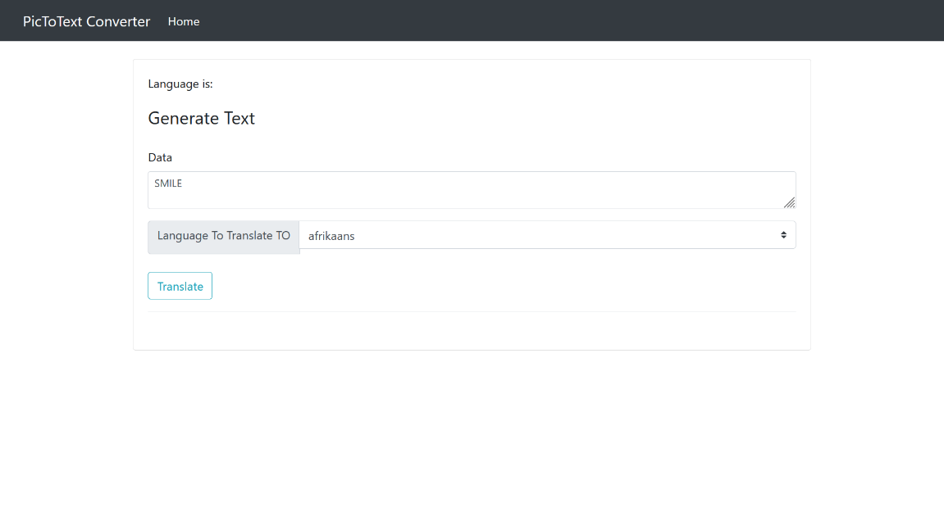
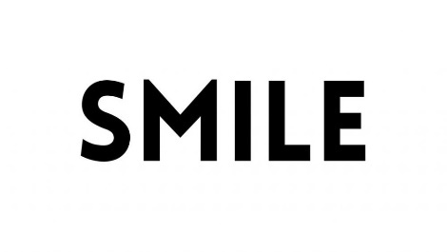

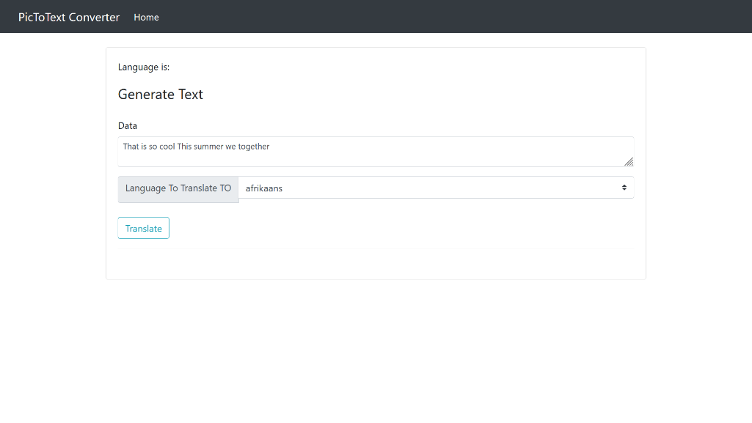
4.2. Short Text
Within this module, a brief text is provided, typically around 10 characters or just a single sentence. The accuracy of the output is reliable, as it effectively detects the image and extracts the text. Users have the capability to input a sentence into the module, which then extracts the text for display in the text field. Should the user wish to make any edits to the extracted text, they can conveniently do so within the text field.
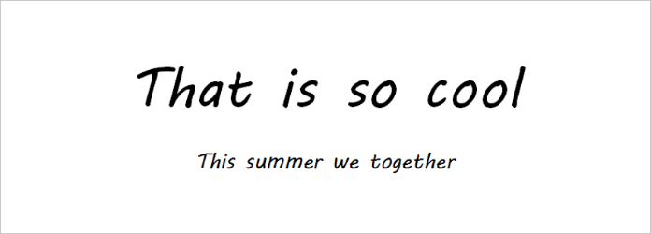

4.3. Long Text
This makes it a valuable tool for researchers, students, and professionals who need to analyze and extract information from large volumes of text quickly and efficiently. The module's advanced algorithms and machine learning capabilities enable it to accurately interpret and extract text from various Images, making it a versatile and reliable tool for text processing tasks. Its ability to handle lengthy texts and extract information accurately makes it a valuable asset for any individual or organization.
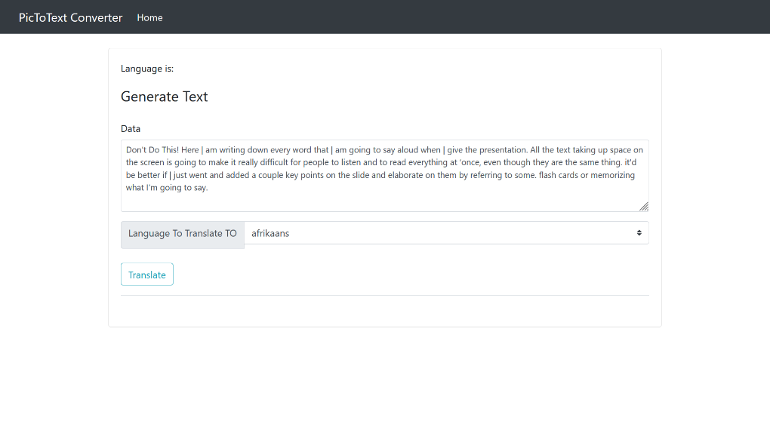
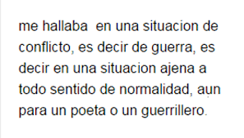
  - . Handwritten Text
The functionality of this module extends to the detection of handwritten text as well. By providing an image of handwritten text, the module is capable of extracting the text from it. However, a notable drawback of this module is its lack of consistent accuracy in producing the desired output. At times, the output may not be entirely precise, while at other times it may be accurate. Consequently, when it comes to handwritten text, the module does not perform as effectively as it does with plain text. Thus, this module is limited in its effectiveness with handwritten text.
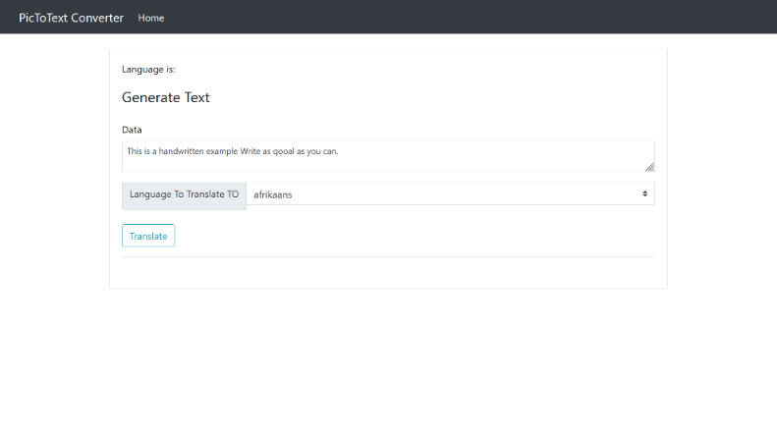
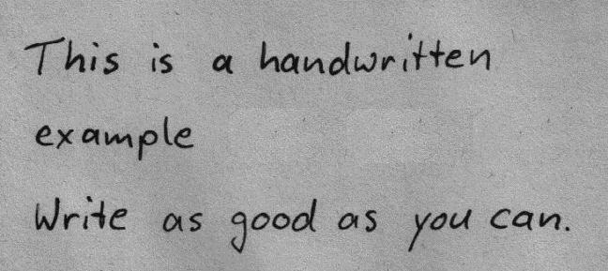
4.5. Other Languages
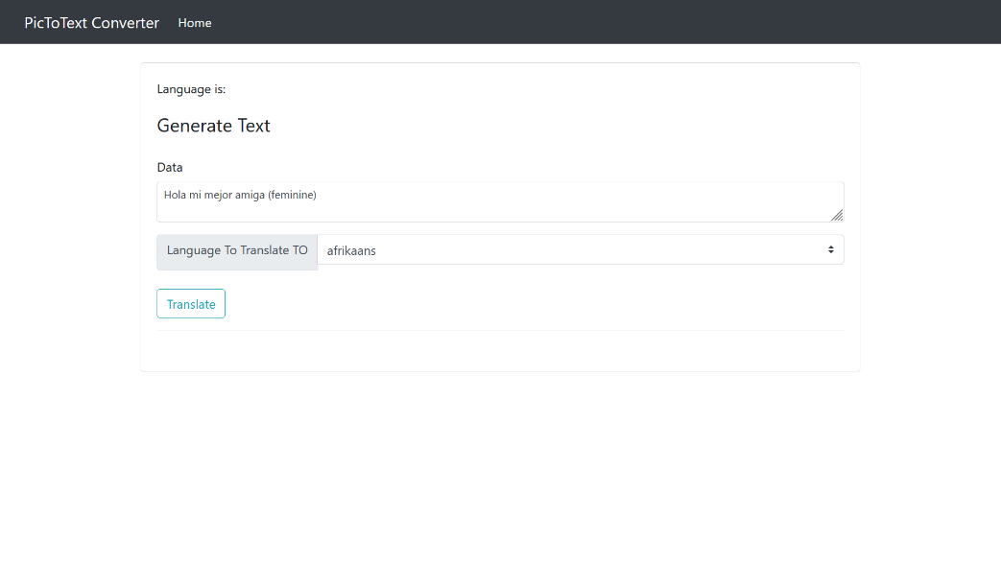
The module is designed to detect various languages, including Spanish, Italian, Japanese, and more. When a user provides an image containing text in a different language, such as Spanish, Italian, or Japanese, this module accurately identifies and detects the text in that specific language. In addition to English, this module has the capability to accurately detect and analyze text in multiple languages, making it a versatile tool for users who work with diverse language content.
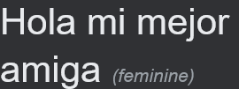
4.6. Convert Text
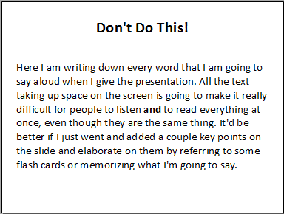
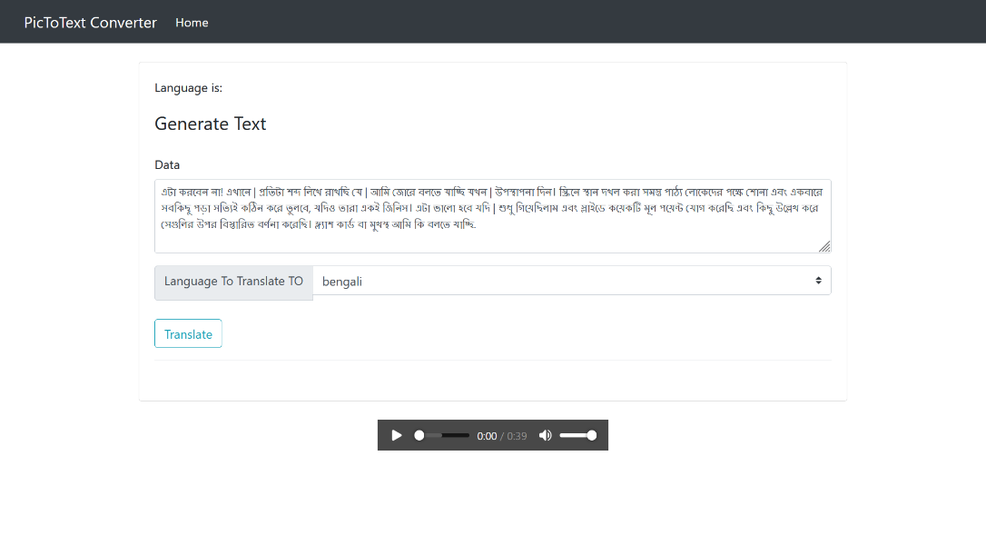
This module is not limited to just detecting text from an image; it also possesses the capability to translate the text into various languages. In cases where an image contains text in a language that the user is unable to comprehend, this module allows for the conversion of the text into a language that the user can understand.
4.7. Audio Generation
The purpose of this module is not to identify and translate text into various languages. Instead, its main function is to create an audio representation of the text extracted from an image. This feature greatly enhances the user's comprehension of the text, making it more valuable and easily understandable. By converting text into audio, this module caters to individuals who may have difficulty reading or understanding written text, such as those with visual impairments or learning disabilities. It also provides a convenient way for users to consume information on the go, as they can listen to the audio representation while multitasking or engaging in other activities. Furthermore, this module can be particularly useful in educational settings, where students can benefit from hearing the text read aloud to them. This auditory reinforcement can aid in retention and comprehension, ultimately improving the learning experience for students of all ages. Overall, the primary goal of this module is to make information more accessible and inclusive for all users, regardless of their language proficiency or reading abilities. By offering an audio representation of text, this feature enhances the overall user experience and ensures that everyone has equal access to the content.

Table 1: Result Summary
Test Id | Test Case | Description | Expected | Result
T01 | Plain Text | Data related to plain text | Detect the plain text from the image | Pass
T02 | Short Text | Input should have 20 character or one sentence | Detect the sentence from the image of the text | Pass
T03 | Long Text | Input should have long paragraph | Detect the long paragraph from the image | Pass
T04 | Handwritten Text | Input should have handwritten text. Not plain text | Detect and recognize the text from the hand written text | Not Accurate. Sometime model give accurate result and sometime it doesn’t
T05 | Convert the text | Input could be any text.It convert to any specific language | It detect text and user can convert it to any languages | Pass
T06 | Convert the text | Input could be any text.It convert to any specific language | It detect text and user can convert it to any languages | Pass
T07 | Audio generation | Input could be any text. It detect the text and generate an audio of the text | It generate the audio of the text which is detected from the image | Pass

Chapter 5- Conclusion and Future Scope

The project involved the utilization of pytesseract, a Python library, for text detection and extraction from images. This library allowed us to extract text from images and convert it into a readable format. To develop the project, we employed various tools such as Python, Flask, and Gtts. Python served as the primary programming language for the project, providing a robust and flexible environment for development. Flask, a web framework, was used to create a user-friendly interface for the web application. Gtts, which stands for Google Text-to-Speech, was used to generate audio from the extracted text.
The integration of these tools resulted in the creation of a web application that allowed users to upload images containing text. Once uploaded, the application utilized pytesseract to extract the text from the image and displayed it in a designated field. This feature enabled users to easily access and read the text without the need for manual transcription.
Furthermore, the application provided additional functionalities to enhance user experience. Users were able to edit the extracted text, making any necessary changes or corrections. Additionally, the application offered translation capabilities, allowing users to convert the text into different languages. This feature was particularly useful for users who needed to understand text in a language they were not familiar with.
One of the standout features of the project was the ability to generate audio from the extracted text. By utilizing Gtts, the application could convert the text into speech, providing an auditory representation of the image's content. This feature was especially beneficial for users with visual impairments or those who preferred to listen rather than read.
Overall, the project successfully integrated pytesseract, Python, Flask, and Gtts to develop a web application that allowed users to upload images containing text. The application provided text extraction, editing, translation, and audio generation capabilities, enhancing the accessibility and usability of the image's content.
The project's future prospects involve enhancing the accuracy of handwritten text recognition. Currently, there are instances where the model fails to accurately detect text from handwritten images. Therefore, our primary objective is to improve the accuracy in such cases and introduce an additional feature known as text summarization. This feature will assist readers in comprehending the meaning of lengthy paragraphs that are generated as output from an image.

Appendix

References

